# **NAME: MUHAMMAD MUBASHIR**

# **FATHER NAME: SAEED AKBER**

# **COURSE: MOBILE APPLICATION**

# **COURSE INSTRUCTOR: SALMAN BEDIYA**

**Concept of Dart Programming Language**

**Assignment 1 Question Task**

1.Check whether a given year is a leap year or not?

2.Check whether a given year is a leap year or not?

3.Check the maximum number between two numbers.

4.Check if a number is positive or negative.

5.Check whether a number is divisible by 5 and 11 or not.

**Assignment 2 Question Task**

6.Write a program to check if a given string is a palindrome.\

7.Write a program to calculate the factorial of a given number using a function.

8.Write a program to print out the Fibonacci sequence up to a given number.

9.Write a program to calculate the distance between two points on a 2D plane using a function.

10. Write a program to convert a temperature from Fahrenheit to Celsius using a function.

11.Write a program to calculate the area of a circle using a function.

12.Write a program to print out the prime numbers between 1 and a given number.

**TASK CREATING CLASS CONCEPT**

13.Create a class called "BankAccount" with the following attributes:

account_number (integer)

balance (double)

account_type (string)

interest_rate (double)

And the following methods:

deposit(amount): adds the amount to the balance.

withdraw(amount): subtracts the amount from the balance. You cannot withdraw more than the current balance.

add_interest(): adds interest to the balance based on the interest rate.

display(): prints out the account number, balance, account type, and interest rate.

Then, create two instances of the BankAccount class, each with its own account number, balance, account type, and interest rate.

Finally, call the deposit(), withdraw(), add_interest(), and display() methods on each instance and confirm that the information is updated and displayed correctly.

14.(a)Create a class called "Student" with the following attributes:

name (string)

id (string)

courses (list of strings)

And the following methods:

add_course(course): adds a course to the student's list of courses.

drop_course(course): removes a course from the student's list of courses.

display_courses(): prints out the student's list of courses.

Then, create two instances of the Student class, each with their name, id, and courses.

Finally, call the add_course(), drop_course(), and display_courses() methods on each instance and confirm that the information is updated and displayed correctly.

**Password Generate Task**

15.(a)Write a program that generates a random password based on the user's specifications. The user should be able to specify the length of the password and whether it should include numbers, letters, and special characters.

(b)Write a function that takes a string input from the user and checks if the password is strong enough based on certain criteria (e.g. minimum length, use of uppercase letters, use of special characters, etc.).

**If Else Condition**

16.Write a program that takes an integer input from the user and prints out numbers from 1 to that integer, but for multiples of 3 print "Fizz" instead of the number, and for multiples of 5 print "Buzz". For numbers that are multiples of both 3 and 5, print "FizzBuzz".

17.Write a function that takes a list of numbers as input and sorts the list in ascending order.

**TASK INHERITANCE**

18.Calculate area of different shapes. Create a base class named “Shape” with a method to return the CalculateArea of the shape. Create a class named “Rectangle”, “Circle” and “Square” derived from the base class “Shape”.

# ***TASK 1 to 5***

|  |  |
| --- | --- |
| TASK 1 | OUTPUT |
| //Check whether a given year is a leap year or not?  Void main(){  int year = 2024  // int year = 2025;    if ((year % 4 == 0 && year % 100 !=0) || year % 400 == 0){  print('$year is a leap Year');  }  else{  print("$year is not a leap Year");  }  } | C:\Users\djboy\Pictures\Screenshots\Screenshot (42).png    C:\Users\djboy\Pictures\Screenshots\Screenshot (43).png |

|  |  |
| --- | --- |
| TASK 2 | OUTPUT |
| // Program to check the grade of a student from total marks with the criteria like A = >80, B = >70, etc.  void main(){  // int a = 39;  // int a = 89;  int a = 79;  if(a>80 && a<100){  print("A+ Grade");  }    else if(a>70 && a<80){  print("A Grade");  }    else if(a>60 && a<70){  print("B Grade");  }  else if(a>50 && a<60){  print("C Grade");  }    else if(a>40 && a<50){  print("D Grade");  }    else if(a>33 && a<40){  print("E Grade");  }    else if(a>0 && a<33){  print("F Grade");  }  else{  print(“Correct the valid input”);  }  } | C:\Users\djboy\Pictures\Screenshots\Screenshot (44).png  C:\Users\djboy\Pictures\Screenshots\Screenshot (45).png  C:\Users\djboy\Pictures\Screenshots\Screenshot (46).png |

|  |  |
| --- | --- |
| TASK 3 | OUTPUT |
| // Check the maximum number between two numbers  void main(){  var a, b;  a = 95;  b = 37;  // a = 35;  // b = 87;    if(a>b){  print("$a is a maximum number");  }    else if(a<b){  print("$a is a minimum number");  }  } |  |

|  |  |
| --- | --- |
| TASK 4 | OUTPUT |
| // Check if a number is positive or negative  void main() {  var b = 0;  var num1 = 29;  // var num1 = -55;  if(num1>b){  print("$num1 It is a positive number");  }  else if(num1<b){  print("$num1 It is a negative number");  }  } | C:\Users\djboy\Pictures\Screenshots\Screenshot (50).png  C:\Users\djboy\Pictures\Screenshots\Screenshot (49).png |

|  |  |
| --- | --- |
| TASK 5 | OUTPUT |
| // Check whether a number is divisible by 5 and 11 or not.  void main() {  int a, b ,c;  a=5;  b=11;  // c = 89;  c = 55;  if(c % a == 0 && c % b == 0)  {  print("$c Divisible by 5 and 11");  }  else{  print("$c Not Divisible by 5 and 11");  }  } | C:\Users\djboy\Pictures\Screenshots\Screenshot (51).png  C:\Users\djboy\Pictures\Screenshots\Screenshot (52).png |

# ***Assignment 2***

1. Write a program to check if a given string is a palindrome.

void main(){

checkpalindrome("civic")? print("its is palindrome word") :

print("its is not palindrome word");

checkpalindrome("hello")? print("its is palindrome word") :

print("its is not palindrome word");

checkpalindrome("abba")? print("its is palindrome word") :

print("its is not palindrome word");

checkpalindrome("")? print("its is palindrome word") : print("its is not palindrome word"); checkpalindrome("amma")? print("its is palindrome word") :

print("its is not palindrome word");

}

bool checkpalindrome(String user){

return user == user.split("").reversed.join();

}

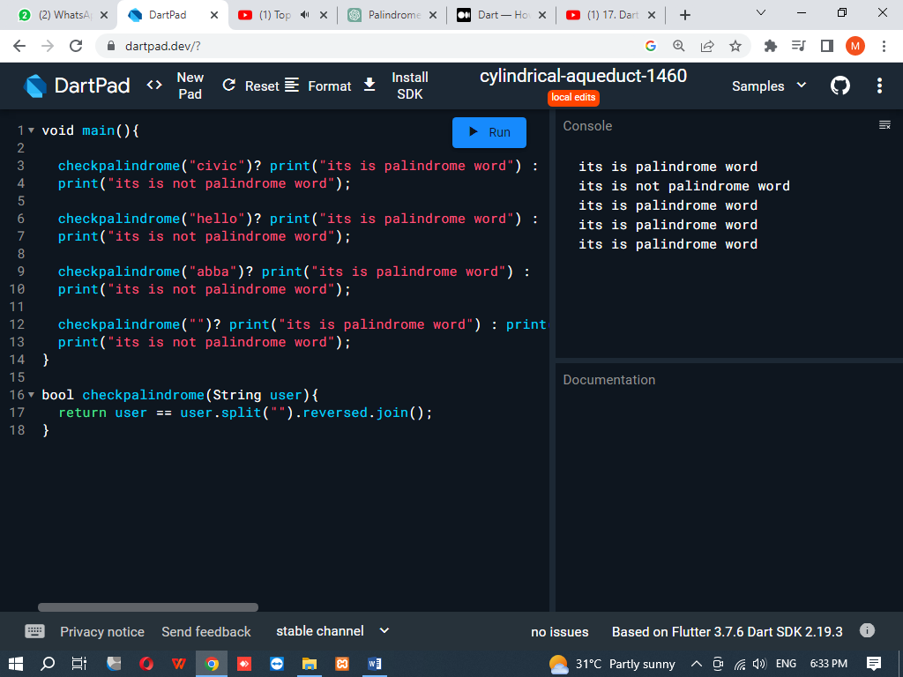

1. Write a program to calculate the factorial of a given number using a function.

void main()

{

factorial(8);

}

void factorial(int a)

{

int fact=1;

for(int i=1; i<=a; i++){

fact=fact*i;

}

print("The factorial of $a is $fact");

}

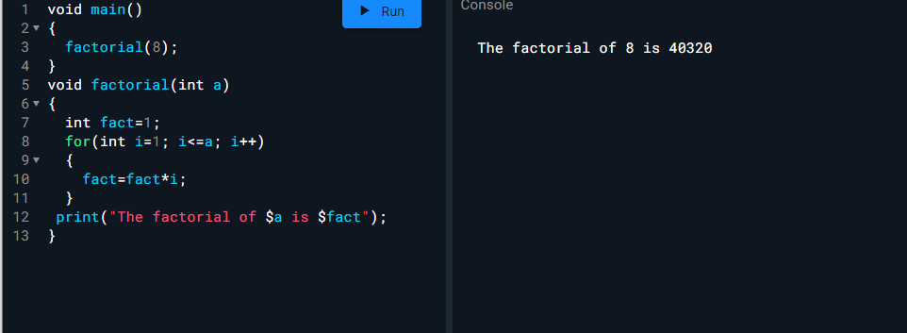

1. Write a program to print out the Fibonacci sequence up to a given number.

void main() {

fibonacci(55);

}

void fibonacci(int a){

int b = 0;

int c = 1;

int d;

print('Fibonacci sequence up to $a:');

print(b);

print(c);

for (int i = 2; i <=a; i++) {

d = b + c;

if (c > a) {

break;

}

print(c);

b = c;

c = d;

}

}

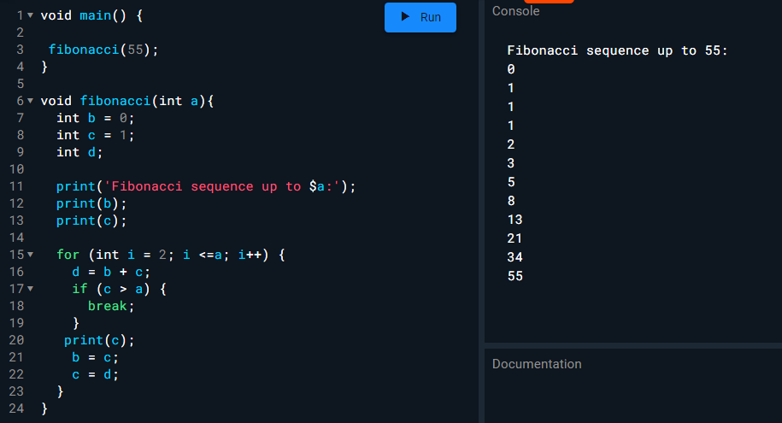

**4. Write a program to calculate the distance between two points on a 2D plane using a function.**

import 'dart:math';

void main() {

// example coordinates

var point1 = Point(3, 5);

var point2 = Point(1, 9);

var distance = calculateDistance(point1, point2);

print('The distance between $point1 and $point2 is $distance');

}

double calculateDistance(Point p1, Point p2) {

var xDiff = p2.x - p1.x;

var yDiff = p2.y - p1.y;

var distance = sqrt(pow(xDiff, 2) + pow(yDiff, 2));

return distance;

}

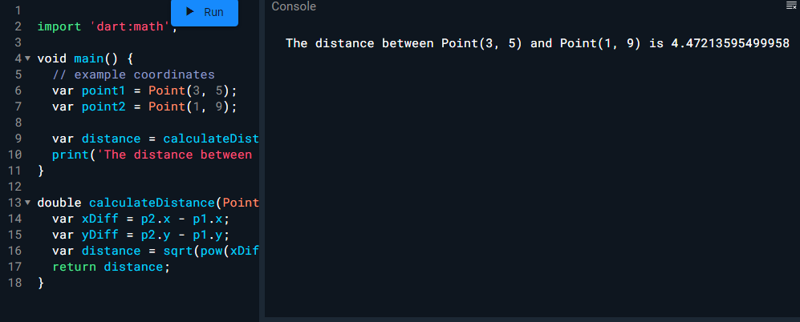

**5. Write a program to convert a temperature from Fahrenheit to Celsius using a function**

void main() {

// example Fahrenheit temperature

dynamic fahrenheit=90;

var celsius = convertFahrenheitToCelsius(fahrenheit);

print('$fahrenheit°F is equal to $celsius°C');

}

double convertFahrenheitToCelsius(double fahrenheit) {

var celsius = (fahrenheit - 32) * 5 / 9;

return celsius;

}

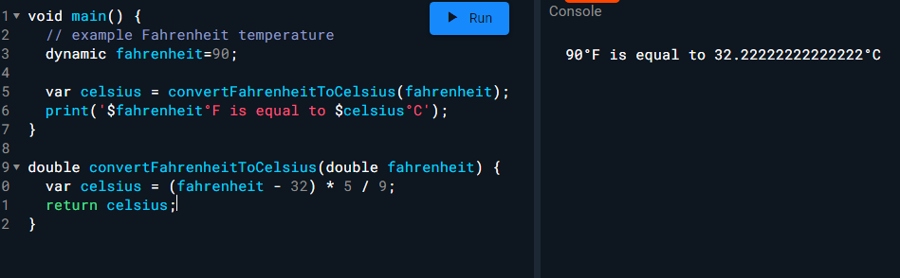

1. **Write a program to calculate the area of a circle using a function.**

import 'dart:math';

void main() {

// example circle radius

dynamic radius = 10;

var area = calculateCircleArea(radius);

print('The area of a circle with radius $radius is $area');

}

double calculateCircleArea(double radius) {

var area = pi * pow(radius, 2);

return area;

}

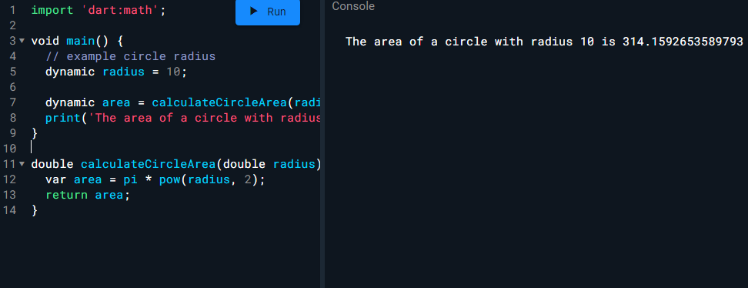

**7. Write a program to print out the prime numbers between 1 and a given number.**

import 'dart:math';

void main() {

// example upper limit

var limit = 30;

print('The prime numbers between 1 and $limit are:');

for (var i = 2; i <= limit; i++) {

if (isPrime(i)) {

print(i);

}

}

}

bool isPrime(int number) {

if (number <= 1) {

return false;

}

for (var i = 2; i <= sqrt(number); i++) {

if (number % i == 0) {

return false;

}

}

return true;

}

**Question:1**

Create a class called "BankAccount" with the following attributes:

account_number (integer)

balance (double)

account_type (string)

interest_rate (double)

And the following methods:

deposit(amount): adds the amount to the balance.

withdraw(amount): subtracts the amount from the balance. You cannot withdraw more than the current balance.

add_interest(): adds interest to the balance based on the interest rate.

display(): prints out the account number, balance, account type, and interest rate.

Then, create two instances of the BankAccount class, each with its own account number, balance, account type, and interest rate.

Finally, call the deposit(), withdraw(), add_interest(), and display() methods on each instance and confirm that the information is updated and displayed correctly.

void main()

{

  BankAccount account1 = BankAccount("Saving",49516,10000,1.9);

  BankAccount account2 = BankAccount("Saving",30293,50000,4.9);

  print("First account information");

  account1.deposit(7000);

  account1.withdraw(2500);

  account1.addInterest();

  account1.display();

  print("Second account information");

  account2.deposit(9000);

  account2.withdraw(3500);

  account2.addInterest();

  account2.display();

}

class BankAccount{

  String accountType;

  int accountNumber;

  double balance;

  double interestRate;

BankAccount(this.accountType,this.accountNumber,this.balance,this.interestRate);

void deposit(double amount)

{

  balance = balance + amount;

  print(balance);

}

void withdraw(double amount)

{

  if(amount <= balance){

  balance = balance - amount;

  print(balance);

  }

  else{

    print("You cannot withdraw more than the current balance.");

  }

}

void addInterest()

{

  double interest = ( balance * (interestRate/100));

  balance = balance + interest;

  print(balance);

}

void display(){

  print("My Account type is $accountType");

  print("Account  Number is $accountNumber");

  print("Balance is $balance");

  print("My interest Rate is is $interestRate");

}

}

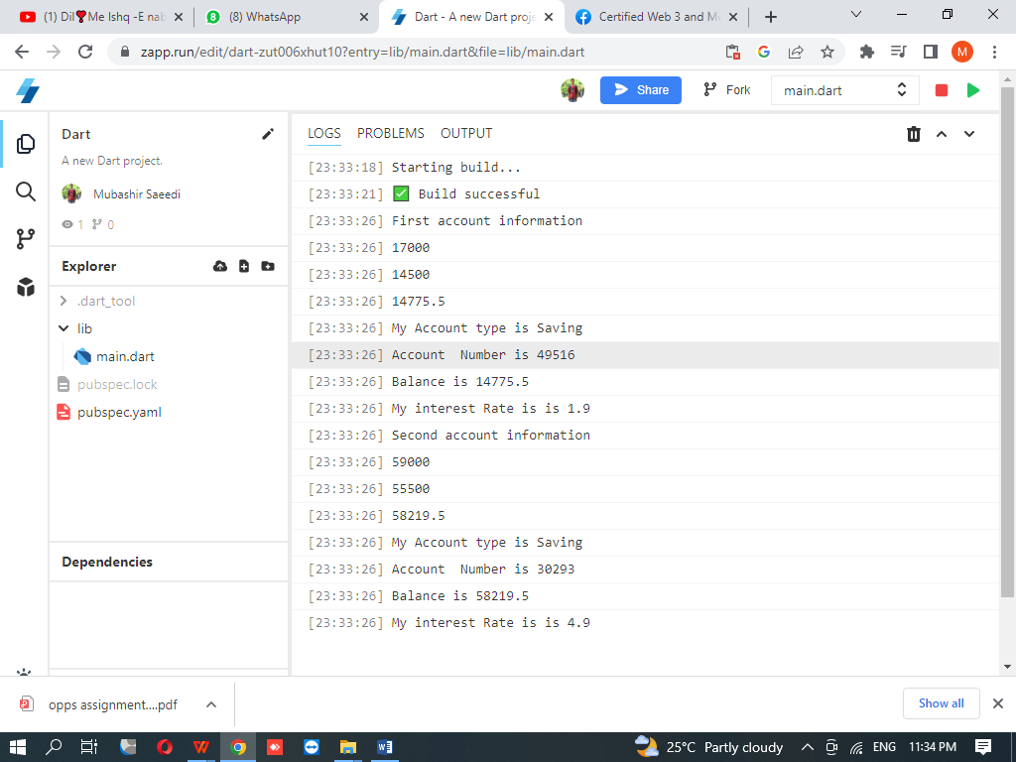

**Question:2**

Create a class called "Student" with the following attributes:

name (string)

id (string)

courses (list of strings)

And the following methods:

add_course(course): adds a course to the student's list of courses.

drop_course(course): removes a course from the student's list of courses.

display_courses(): prints out the student's list of courses.

Then, create two instances of the Student class, each with their name, id, and courses.

Finally, call the add_course(), drop_course(), and display_courses() methods on each instance and confirm that the information is updated and displayed correctly.

void main(List<String> args)

{

 print("First Student Information");

 Student stud1 = Student("Asad","201A-F22-005",["computer,Urdu"]);

 stud1.add_course("Physics");

 stud1.drop_course("Chemistry");

 stud1.display_courses();

 print("Second Student Information");

 Student stud2 = Student("Bawany","BSE-22S-082",["English,Urdu"]);

 stud2.add_course("ICT");

 stud2.drop_course("DSA");

 stud2.display_courses();

}

class Student

{

 String name;

 String id;

 List <String> courses;

 Student(this.name,this.id,this.courses);

 void add_course(String course)

 {

  courses.add(course);

 }

 void drop_course(String course)

 {

  courses.remove(course);

 }

 void display_courses()

 {

  print('${name}\'s courses: ${courses.join(",")}');

 }

 }

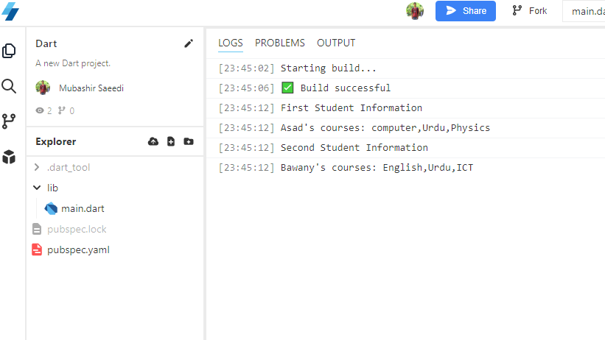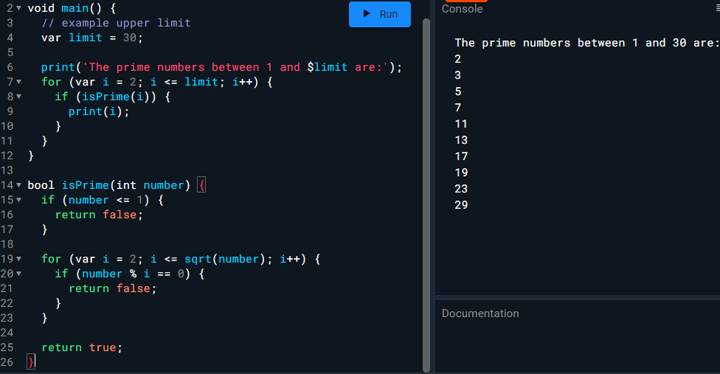

# ***Class Quiz # 01***

Q#1:

(a)Write a program that generates a random password based on the user's specifications. The user should be able to specify the length of the password and whether it should include numbers, letters, and special characters.

import 'dart:math';

void main(){

int length = 11;

bool should_Allow_Letr = true;

bool should_Allow_Nmbr = true;

bool should_Allow_Spec = true;

print(gen_Pas(length,should_Allow_Letr,should_Allow_Nmbr,should_Allow_Spec));

}

String gen_Pas(int length,bool should_Allow_Letr,bool should_Allow_Nmbr,bool should_Allow_Spec){

String alpha = "abcdefghijklmnopqrstuvwxyz";

String numb = "0123456789";

String special = ",./';][]<>?!@#%^&*()_+=-|\~'";

String user_specif = "";

if(should_Allow_Letr == true){

user_specif = user_specif + alpha;

}

if(should_Allow_Nmbr == true){

user_specif = user_specif + numb;

}

if(should_Allow_Spec == true){

user_specif = user_specif + special;

}

String password = "";

for(int i = 0; i<length; i++){

int index = Random().nextInt(user_specif.length);

print(user_specif[index]);

}

return password;

}

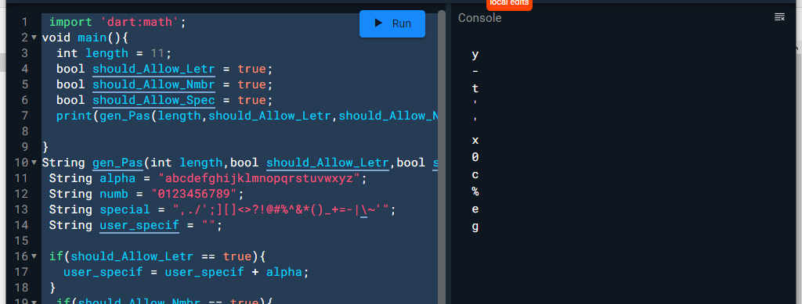

(b)

Write a function that takes a string input from the user and checks if the password is strong enough based on certain criteria (e.g. minimum length, use of uppercase letters, use of special characters, etc.).

Q#2:

Write a program that takes an integer input from the user and prints out numbers from 1 to that integer, but for multiples of 3 print "Fizz" instead of the number, and for multiples of 5 print "Buzz". For numbers that are multiples of both 3 and 5, print "FizzBuzz".

void main(){

  int a = 15;

  for(int i = 0; i<=55; i++){

    if(a%3 == 0 && a%5 == 0)

    {

      print("Fizz Buzz");

    }

    else if(a%3 == 0)

    {

      print("Fizz");

    }

    else if(a%5 == 0)

    {

      print("Buzz");

    }

  }

}

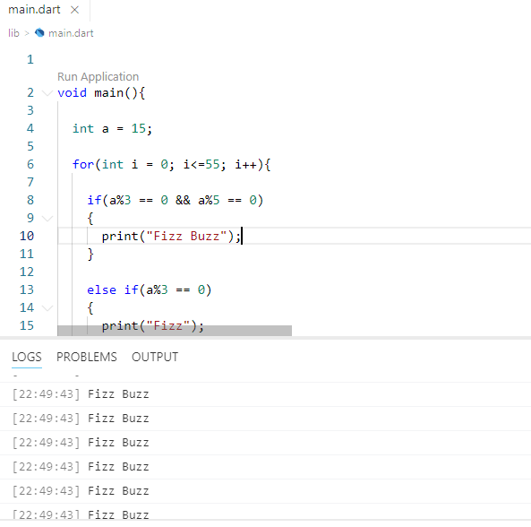

Q#3:

Write a function that takes a list of numbers as input and sorts the list in ascending order.

void main(){

List<int> Sequence = [4,6,1,2,8];

print("Before Sorting $Sequence");

Sequence.sort();

print("After Sorting $Sequence");

}

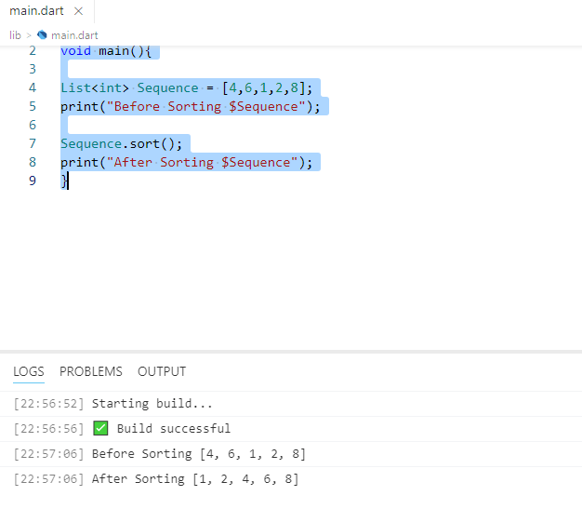

# ***TASK INHERITANCE***

Calculate area of different shapes

void main()

{

Square sq = Square(4);

sq.CalculateArea();

Circle cr = Circle(7);

cr.CalculateArea();

Rectangle rec = Rectangle(5,9);

rec.CalculateArea();

}

class Shape

{

    double? cal;

    void CalculateArea()

    {

     print("Calculate the Area is $cal");

    }

}

class Square extends Shape

{

  double sqr;

  Square(this.sqr);

  @override

  void CalculateArea()

  {

  cal = sqr*sqr;

  super.CalculateArea();

  }

}

class Circle extends Shape

{

  int cr;

  Circle(this.cr);

  @override

  void CalculateArea()

  {

  cal = 3.142*cr*cr;

  super.CalculateArea();

  }

}

class Rectangle extends Shape

{

  double len;

  double bre;

  Rectangle(this.len,this.bre);

  @override

  void CalculateArea()

  {

  cal = (len*bre);

  super.CalculateArea();

  }

}

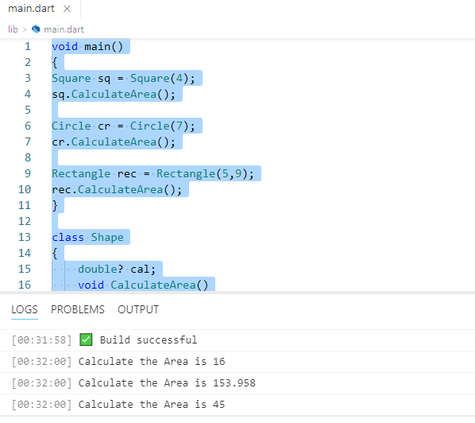

**Concept of Constructor**

**-------------------------------------------Main Page------------------------------------**

import 'student.dart';

void main(){

  Student info = Student();

  info.information();

}

**-------------------------------------------Other Page-----------------------------------**

class Student{

  String? _name;

  int? roll;

void information(){

  this._name = "Asad";

  this. roll = 59;

  print(_name);

  print(roll);

}

}

**Invoked a Constructor by default**

**^_^_^_^_^_^_^_^_^_^_^_^_^_^_^_^_^_^_^_^_^_^_^_^_^_^_^_^_^_^_^_^_^_^_**

**-------------------------------------------Main Page------------------------------------**

import 'student.dart';

void main(){

  Student info = Student("Mubashir",16);

  info.information();

}

**-------------------------------------------Other Page-----------------------------------=**

class Student{

  String? _name;

  int? roll;

  Student(this._name, this.roll);

void information(){

  print(_name);

  print(roll);

}

}

**Create a Parameterized Constructor by user**

**^_^_^_^_^_^_^_^_^_^_^_^_^_^_^_^_^_^_^_^_^_^_^_^_^_^_^_^_^_^_^_^_^_^_**

**------------------------------Main Page----------------------------**

import 'student.dart';

void main(){

  Student info = Student(name:"Mubashir",roll:84);

  info.information();

}

**--------------------------------Other Page---------------------------**

class Student{

  String? name;

  int? roll;

Student({this.name, this.roll});

void information(){

  print(name);

  print(roll);

}

}

**Create a Name Constructor by user**

**^_^_^_^_^_^_^_^_^_^_^_^_^_^_^_^_^_^_^_^_^_^_^_^_^_^_^_^_^_^_^_^_^_^_**

**------------------------------Main Page----------------------------**

import 'student.dart';

void main(){

  Student info = Student("mubashir",contact:"03432949516",roll:45);

  info.information();

}

**--------------------------------Other Page---------------------------**

class Student{

  String? _name;

  int? roll;

  String contact;

Student(this._name,{required this.contact, this.roll=54});

void information(){

  print(_name);

  print(roll);

  print(contact);

}

}

**Create a Optional Constructor by user**

**^_^_^_^_^_^_^_^_^_^_^_^_^_^_^_^_^_^_^_^_^_^_^_^_^_^_^_^_^_^_^_^_^_^_**